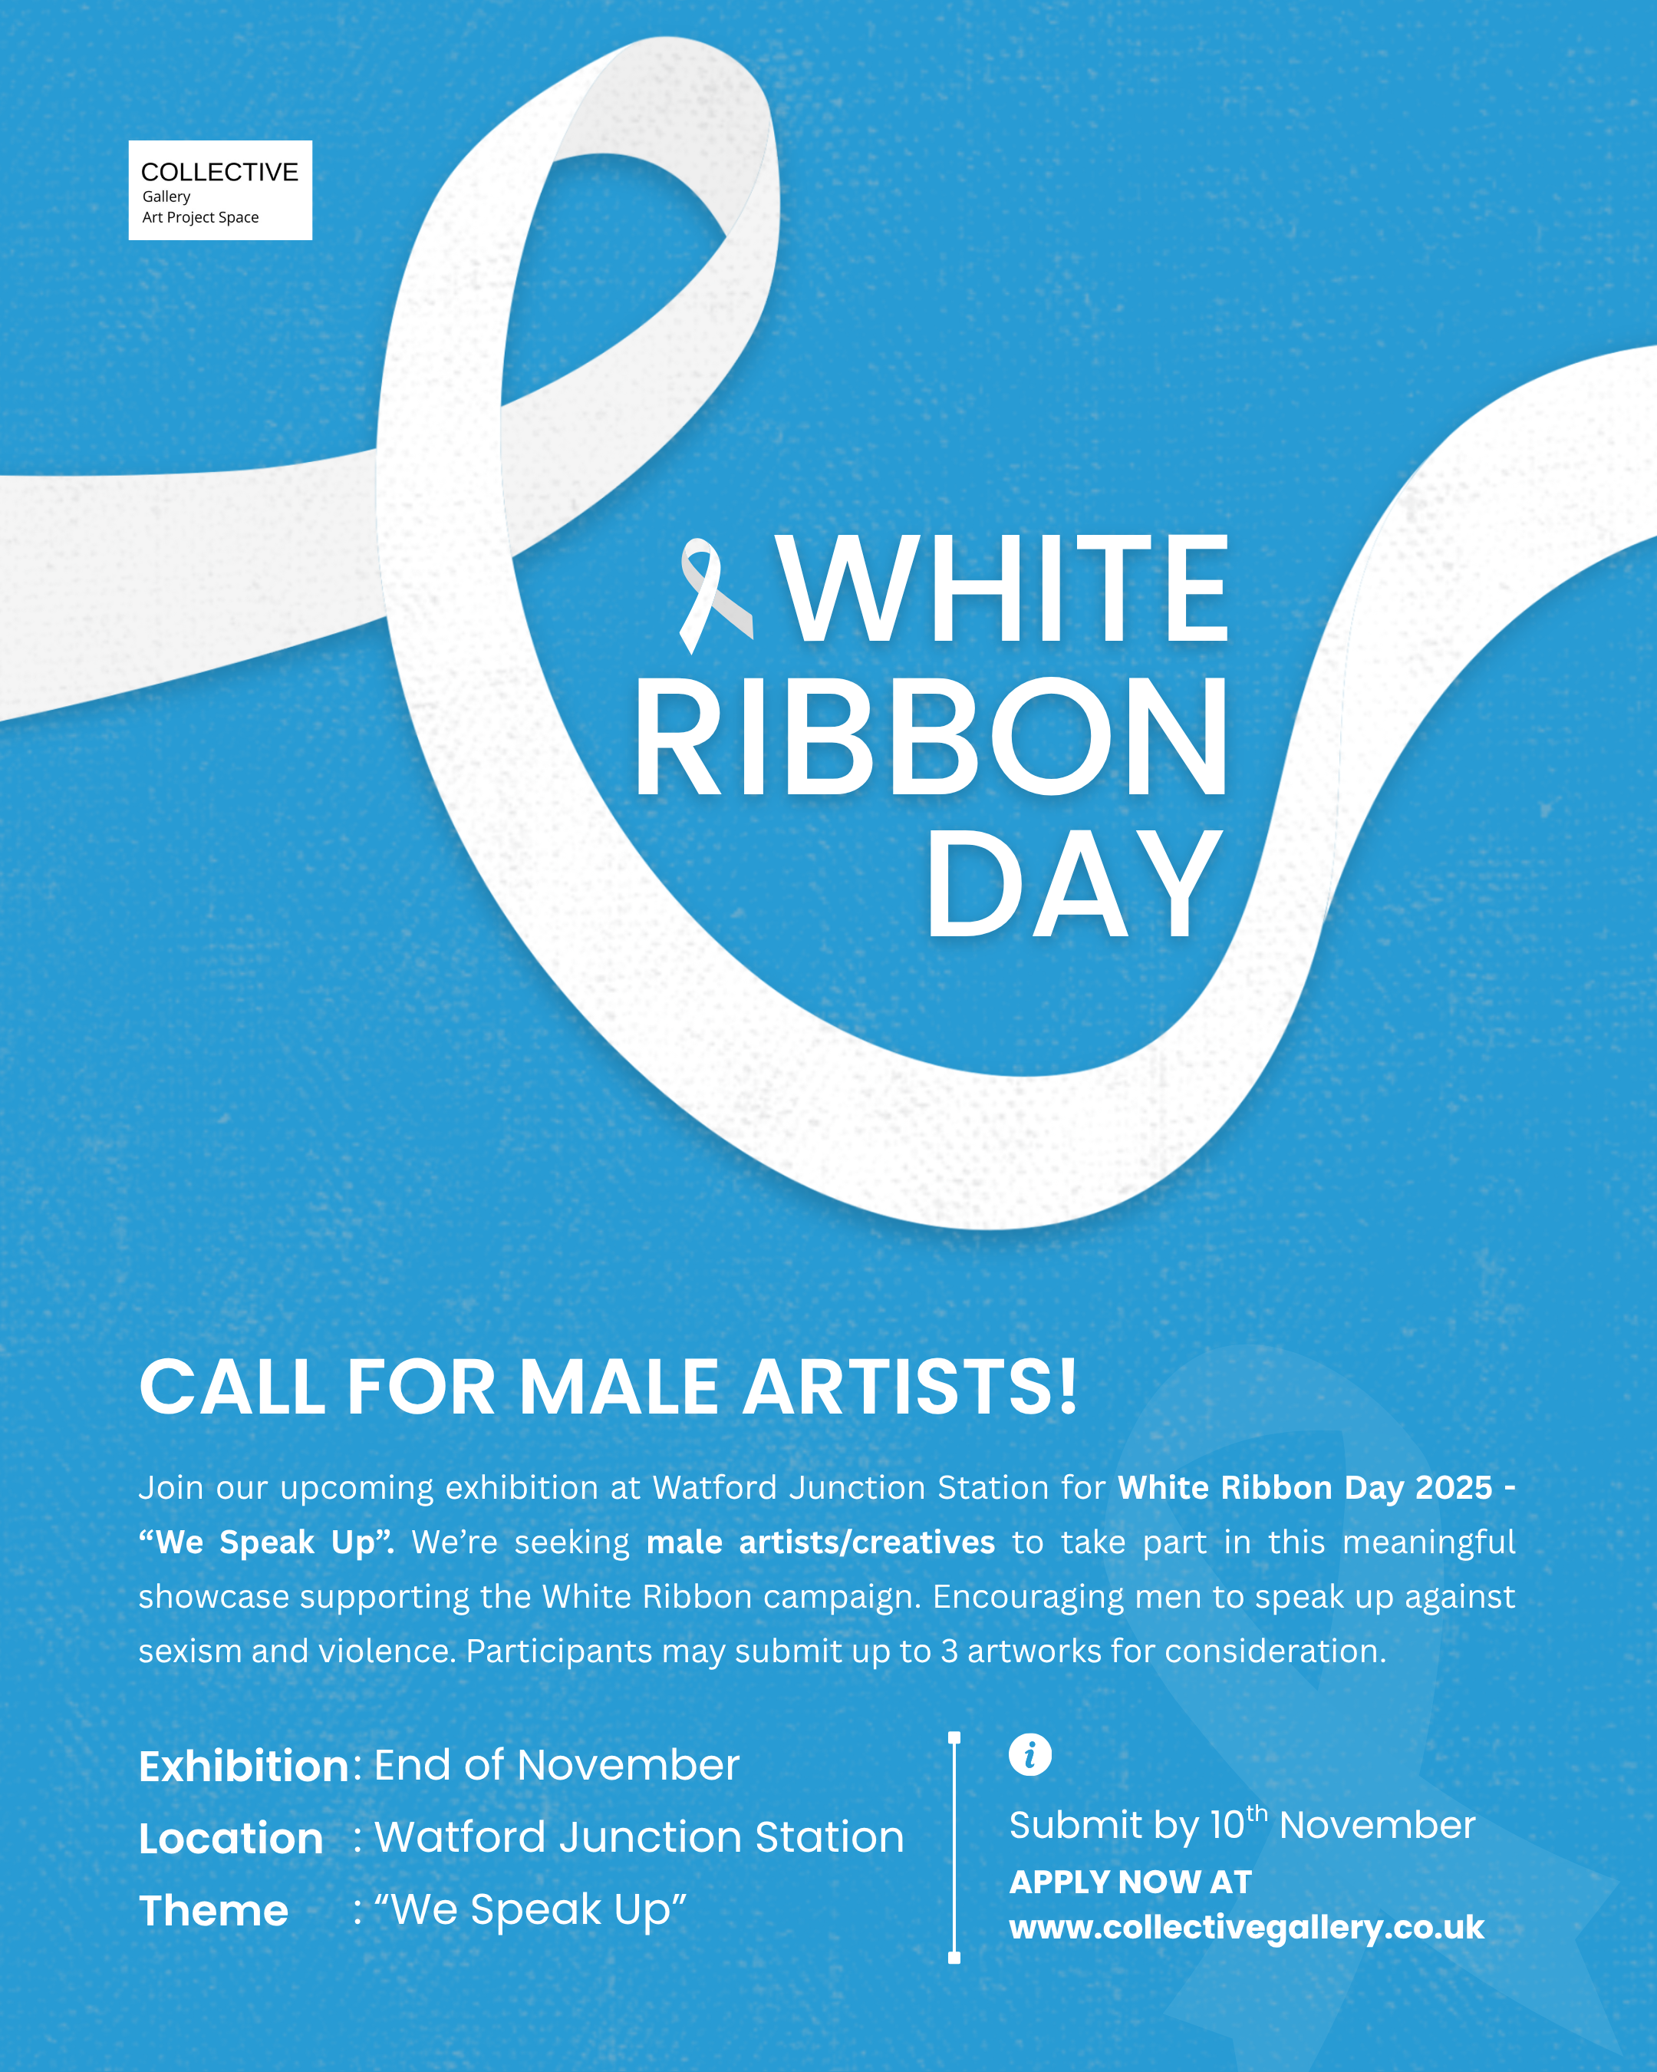
OPEN CALL
WHITE RIBBON DAY – “We Speak Up”
NOVEMBER 2025
Watford Junction Station

As part of the 2025 White Ribbon campaign, this exhibition invites male artists and creatives to use their voices through art - speaking up against sexism and violence, and promoting equality and respect.
Hosted at Watford Junction Station, the exhibition opens at the end of November, coinciding with White Ribbon Day (25 Nov). All mediums are accepted, including painting, photography, digital art, illustration, sculpture, and more.

KEY DATES
10th November 2025 – Deadline for submissions
End of November 2025 – Exhibition opens to the public

SUBMISSIONS / ENTRY
Please download and complete the application form below as a Word document and return it by email to info@collectivegallery.co.uk
Submissions are open until 10th November 2025. A signed form and a clear high-resolution JPEG image of each piece must be submitted by this date. Please ensure that images submitted are:
- In JPG/JPEG format
- Clear and high resolution
- Labelled with: YOUR NAME – TITLE OF WORK – DIMENSIONS – MEDIUM
Up to three pieces of work can be submitted. There is no entry fee.
FEES & SALES
There is no submission or exhibition fee.
Artists will retain all rights to their work. This exhibition is non-selling; the aim is to celebrate and showcase artists’ work as part of White Ribbon Day.
DELIVERY / PREPARATION OF WORK
Artists do not need to deliver physical artwork. Selected works will be professionally printed and displayed in cabinets located on a walkway at the station
PROMOTION / ADVERTISING
Collective Gallery will publicise the exhibition on social media and the website. Digital flyers will be emailed to selected artists to forward to networks and any contact who you would like to see the exhibition. We kindly request that you promote the exhibition on your social media platform. In signing this agreement you agree to this.
CANCELLATION
Collective Gallery reserve the right to cancel, postpone or change the exhibition if necessary. In this instance artists will be contacted by email.

Name:
Artist bio/CV (Please attach as a separate PDF)
Instagram:
IMAGE | TITLE | MEDIUM | DIMENSIONS

PRINT NAME :
SIGNED :
DATE :

